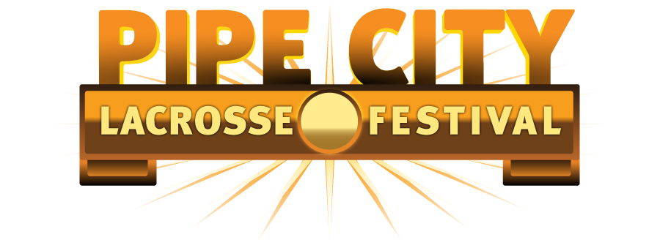

2013 Pipe City Tournament Waiver and Medical Release Form
Each of the undersigned hereby states: I am fully aware and appreciate the risks, including the risk of catastrophic injury, paralysis, and even death, as well as other losses and damages associated with my child’s participation in a full contact lacrosse tournament, clinic, practice, game, camp, program and/or other activities that are sponsored by, hosted by, operated by, arranged by, or otherwise involving Pipe City or Lacrosse America, that take place at facilities owned, leased, or operated by Pipe City or Lacrosse America, including the tournament location, on July 13th and 14th, 2013. I certify that my child is in good mental and physical condition. My child and I understand the inherent risks associated with playing lacrosse and we also understand the inherent risks of participating in this tournament.
I agree on behalf of myself, my heirs and my personal representatives that Lacrosse America, the Pipe City tournament, and their owners, directors, officers, agents, employees, volunteers, and training staff (collectively the “Covered Parties”) shall not be held liable for any injury, damage to personal property, loss of life, or other loss or damage as a result of my child’s participation in the Pipe City Tournament or any activities relating to the Pipe City Tournament or conducted by the Covered Parties. It is my specific intention that none of the Covered Parties shall have any liability whatsoever as a result of or in connection with my child’s participation in the Pipe City Tournament. I hereby waive any claims that I might have against any Covered Parties and release all Covered Parties from any such liability; I agree to indemnify the Covered Parties against any such claims. In addition, I hereby give my consent to Lacrosse America and the Pipe City Tournament its owners and operators and all other Covered Parties to provide, through the medical staff of its choice, customary medical/athletic training attention, transportation and emergency medical services as warranted in the course of my child’s participation in activities related to the Pipe City Tournament. Notwithstanding the foregoing, I understand and agree that none of the Covered Parties have any obligation to provide any such medical/athletic training attention and the lack of any such medical/athletic training attention or the provision thereof on voluntary basis shall be covered by the waiver and release set forth in this paragraph.
Team Name/Division: ____________________________________________________________________________________________
Athlete’s Name (Please Print): _______________________________________________ Athlete’s Date of Birth: ___________
Parent/Guardian’s Name (Please Print): ___________________________________________________________________________
Parent/Guardian Signature: ___________________________________________________ Date: ________________________
Relationship to Athlete: ____________________________________________________ __ Phone: _______________________
Parent Email: _______________________________________________________________
Medical Release
I hereby authorize Lacrosse America and All Covered Parties to obtain necessary medical treatment for the Minor if the Minor is deemed medically unfit by a medical professional and hereby, in my own behalf and on behalf of the Minor, release and hold harmless Releases in the exercises of this authority. I further acknowledge and understand that I will be responsible for any and all medical bills that may be incurred on behalf of the Minor for any illness or injury that the Minor may sustain during the Event and while traveling to and from the site for the Event whether or not the Event actually occurs.
I represent that any medication to which the Minor is allergic or medicates that the Minor is currently taking are listed below. I agree that the Minor shall bring medications which the Minor is currently taking with him/her to the Event and that he /she shall consume the prescribed dosage for such medications by themselves or with their Parent/Guardian. Lacrosse America, the Pipe City Tournament, owners, directors, operators, employees and All Covered Parties are not responsible for administering medication or preventing allergic reactions due to consumption of food, beverage or any other substance, thing, object, inhaling, or touching anything in the surrounding environment of the tournament.
Medications (If Any):_______________________________________________________________________________________________________
Allergies (If Any): _________________________________________________________________________________________________________
Parent Guardian’s Signature: __________________________________________________ Date: ___________________________________
Heath Insurance: __________________________________________________________ Policy Number:___________________________
Coach needs to submit all waiver forms for each player on roster at Check-In on July 12th, 2013 at the Pipe City Tournament. Players will not be allowed to compete without completed form. Only Official Pipe City Lacrosse Festival Waivers will be accepted.

