WORTHINGTON LACROSS MULCH SALE PRODUCT SHEET
BLACK DYE MUCLH |  | CYPRESS
 | 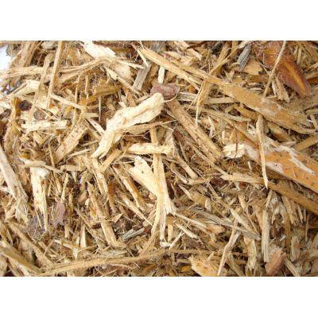
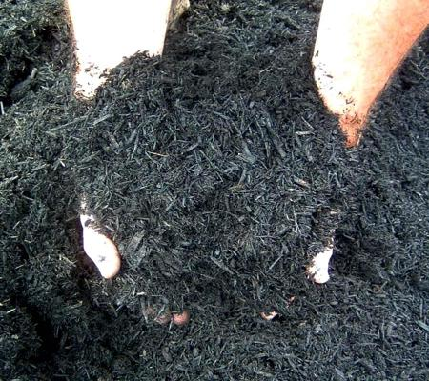

2 Cubic Feet per Bag…………………….$5.50 |  | 3 Cubic Feet per Bag…………………….$5.50
HARDWOOD |  | PINE
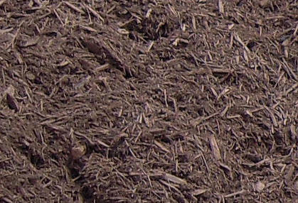 |  | 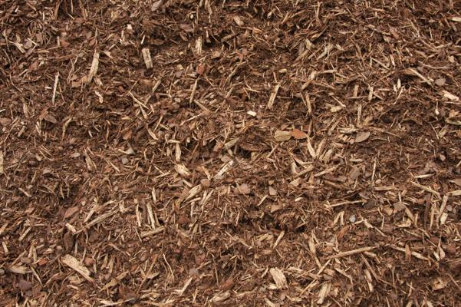
3 Cubic Feet per Bag…………………….$5.50 |  | 3 Cubic Feet per Bag…………………….$5.50

