2009 Liberty Lacrosse Bag Order Form

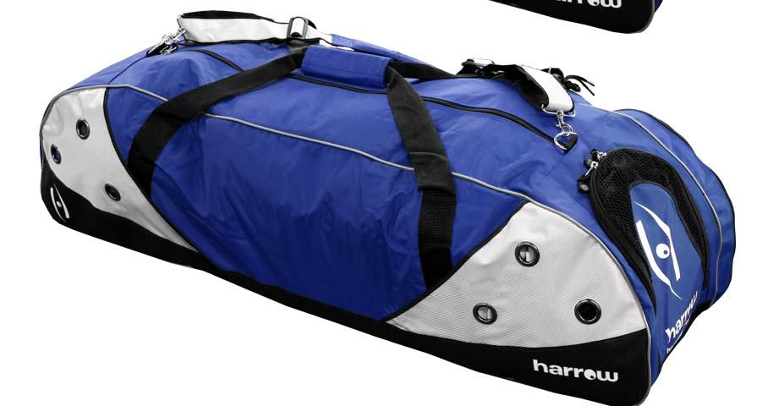

Harrow Blitz 4000 Lacrosse Duffle Bag in Royal/ Silver
“Liberty Lacrosse” embroidered on side of bag
Cost: $56.00

Name: ________________________________________
Phone number: __________________________
Amount: ______________ Check # _______________

Make check payable to: Liberty LAX Boosters
Mail order form and check by February 14th to:

Liberty Lacrosse Boosters
P.O. Box 83
Powell, Ohio 43065

Questions: Contact Margaret Steen (740) 363-8280

